

**National Universityof Computer and Emerging sciences**

**OBJECTIVE:**

Student should understand how a latch or flip-flop works to hold the data and set and reset states.

**APPARATUS:**Logic trainer, Logic probe

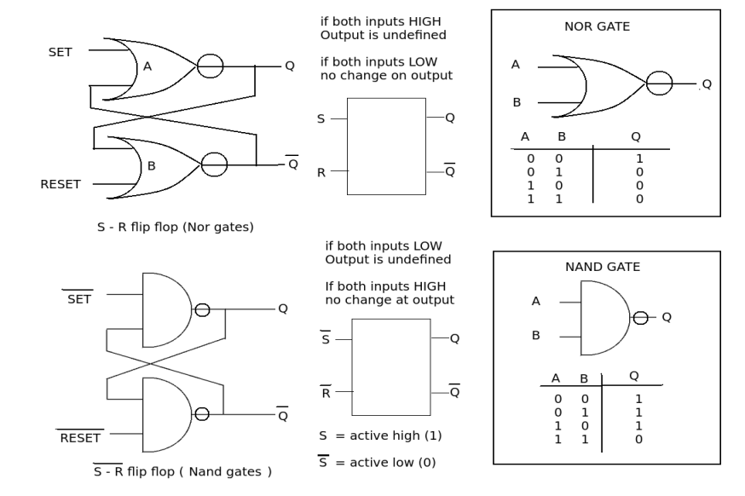

**Lab Task 1; Implement the S'R' Latch on logic works and trainer**

**(implement it using NAND gates)**

**Lab Task 2; Implement the S'R' Latch on logic works and trainer**

**(implement it using NOR gates)**

**Lab Task 3; Implement D latch with control input on logic works and trainer**